Q1. Write a java program to calculate area pirameter of rectangle using class

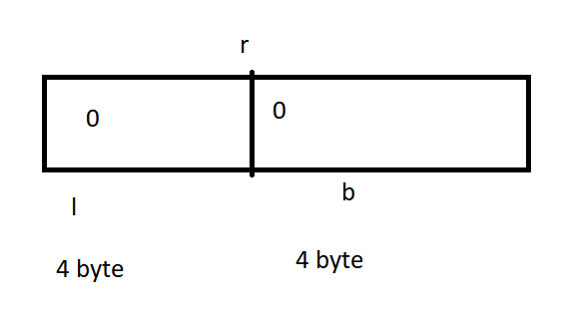

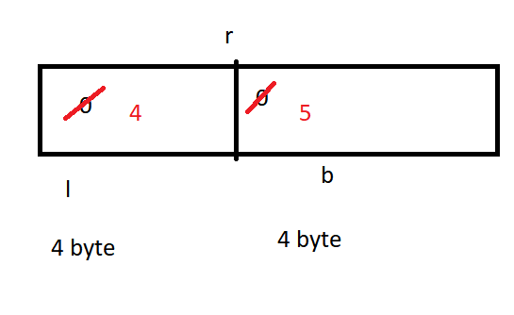

Q1. Write a java program to create student class and perform following operations?

|  |
| --- |
| import java.util.Scanner; // Importing the Scanner class for user input  // Class definition  class Student {  // Instance variables  String name;  String enroll;  float per;  int rollno;  char section;  int p; // Marks in subject P  int c; // Marks in subject C  int m; // Marks in subject M  int e; // Marks in subject E  int h; // Marks in subject H  // Method to get data from user  public void getData() {  Scanner obj = new Scanner(System.in); // Creating Scanner object for input  System.out.print("Enter Name: ");  name = obj.nextLine(); // Getting name from user  System.out.print("Enter Enroll: ");  enroll = obj.nextLine(); // Getting enrollment number from user  System.out.print("Enter Section: ");  section = obj.next().charAt(0); // Getting section from user  System.out.print("Enter P: ");  p = obj.nextInt(); // Getting marks in subject P from user  System.out.print("Enter C: ");  c = obj.nextInt(); // Getting marks in subject C from user  System.out.print("Enter M: ");  m = obj.nextInt(); // Getting marks in subject M from user  System.out.print("Enter E: ");  e = obj.nextInt(); // Getting marks in subject E from user  System.out.print("Enter H: ");  h = obj.nextInt(); // Getting marks in subject H from user  }  // Method to show student data  public void showData() {  // Printing student information  System.out.println("Name: " + name);  System.out.println("Enroll: " + enroll);  System.out.println("Section: " + section);  System.out.println("P: " + p);  System.out.println("C: " + c);  System.out.println("M: " + m);  System.out.println("E: " + e);  System.out.println("H: " + h);  System.out.println("Per: " + per); // This line shows the percentage, but it isn't calculated in this method  }  // Method to calculate and display total marks  public void getTotalmarks() {  System.out.println("Total Marks: " + (p + c + m + e + h)); // Adding marks of all subjects and displaying the total  }  // Method to calculate and display percentage  public void getPercentage() {  per = (p + c + m + e + h) / 5.0f; // Calculating percentage  System.out.println("Per: " + per + "%"); // Displaying percentage  }  // Main method  public static void main(String args[]) {  Student obj = new Student(); // Creating an object of Student class  obj.getData(); // Calling method to get data from user  obj.showData(); // Calling method to display student data  obj.getTotalmarks(); // Calling method to display total marks  obj.getPercentage(); // Calling method to display percentage  }  } |

Q2. Write a java program to create a employee class and perform some basic operations

|  |
| --- |
| import java.util.Scanner; // Importing Scanner class for user input  // Class definition  class EmpInfo {  // Instance variables  String name;  String job;  double bsal;  int deptno;  int hra, da, ta, gs, tn; // Variables for different components of salary  // Method to get data from user  public void getData() {  Scanner obj = new Scanner(System.in); // Creating Scanner object for input  System.out.print("Enter Name = ");  name = obj.nextLine(); // Getting name from user  System.out.print("Enter job = ");  job = obj.nextLine(); // Getting job from user  System.out.print("Enter bsal = ");  bsal = obj.nextFloat(); // Getting basic salary from user  System.out.print("Enter deptno = ");  deptno = obj.nextInt(); // Getting department number from user  }  // Method to show employee data  public void showData() {  System.out.println("Your Name = " + name); // Displaying name  System.out.println("Your Job = " + job); // Displaying job  System.out.println("Your Bsal = " + bsal); // Displaying basic salary  System.out.println("Your DeptNo = " + deptno); // Displaying department number  }  // Method to calculate HRA (House Rent Allowance)  public double getHRA() {  hra = (int) (bsal * 0.20); // Calculating HRA as 20% of basic salary  return hra;  }  // Method to calculate DA (Dearness Allowance)  public double getDA() {  da = (int) (bsal * 0.10); // Calculating DA as 10% of basic salary  return da;  }  // Method to calculate TA (Travel Allowance)  public double getTA() {  ta = (int) (bsal * 0.10); // Calculating TA as 10% of basic salary  return ta;  }  // Method to calculate total incentives (HRA + DA + TA)  public double totalIncentive() {  tn = hra + da + ta; // Adding HRA, DA, and TA to get total incentives  return tn;  }  // Method to calculate gross salary (Basic Salary + Total Incentives)  public double grossSalary() {  gs = (int) (bsal + tn); // Adding basic salary and total incentives to get gross salary  return gs;  }  // Main method  public static void main(String args[]) {  EmpInfo obj = new EmpInfo(); // Creating an object of EmpInfo class  System.out.println();  obj.getData(); // Calling method to get data from user  obj.showData(); // Calling method to display employee data  System.out.println("Total HRA: " + obj.getHRA()); // Displaying HRA  System.out.println("Total DA: " + obj.getDA()); // Displaying DA  System.out.println("Total TA: " + obj.getTA()); // Displaying TA  System.out.println("Total Incentive: " + obj.totalIncentive()); // Displaying total incentives  System.out.println("Total Gross Salary: " + obj.grossSalary()); // Displaying gross salary  }  } |